**Data Engineer**

**Data Engineering:**



**Features of Data Engineering:**

1. **Integration**
2. **Storing**
3. **Analysing**
4. **Scaling**
5. **Processing**
6. **Transformation**

**Imortance:**

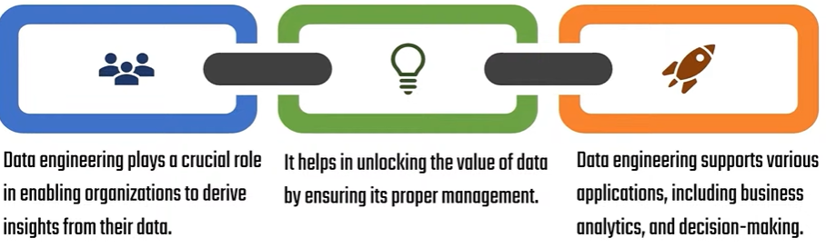

**Applications:**

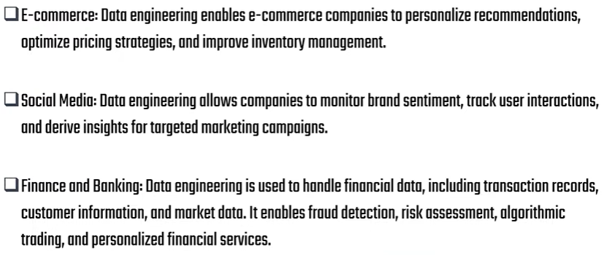

**Data Engineering process:**

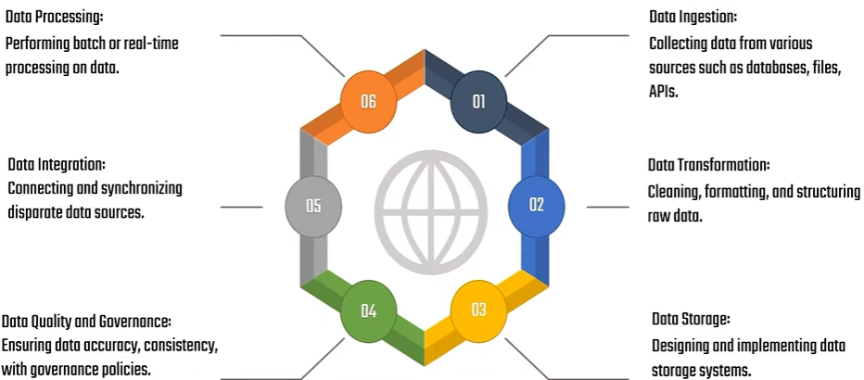

**Key responsibilities of Data Engineers:**

1. **Ensuring data quality**
2. **Building and maintaining Data pipelines**
3. **Designing and implementing scalable and performant data storage**
4. **Collaborate with data analyst for better solutions**

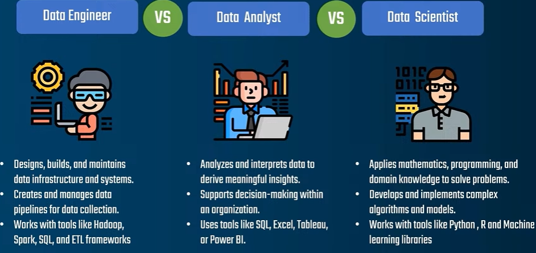

**Data engineer:** Focus on Infrastructure and pipeline

**Data Analyst:** Analyse the organized data and give valuable insights

**Data Scientist:** Advance modelling and extracting insights

**Powerful tools for Data Engineers:**

**Data integration tool:**

1. Apache karfa
2. Apache nifi

**Data Pipeline Orchestration tool:**

1. Apache airflow

**Data base Management system:**

1. Mysql
2. Postgresql

**Distributed Processing framework:**

1. Apache spark
2. Hadoop

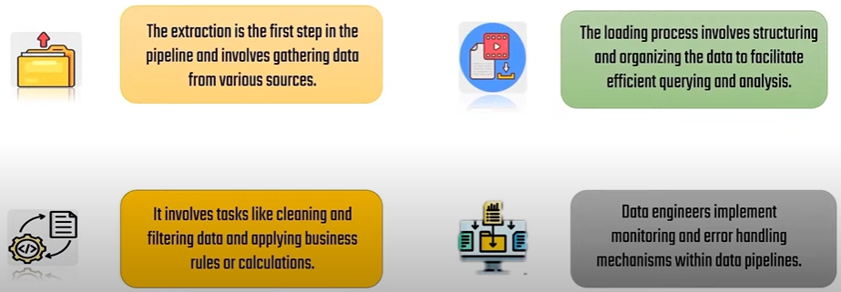

**Batch Processing vs. Real-time Streaming (Simple Explanation) 🚀**

**📌 Batch Processing (Processes data in bulk)**

* **Works with stored data** → Collects data first, then processes it later.
* **Best for large historical data** → Like **monthly sales reports or payroll processing**.
* **Used in frameworks like** → **Apache Spark, Hadoop MapReduce**.
* **Example:**
  + A bank **calculates all daily transactions** and updates balances **at the end of the day** (not instantly).

**📌 Real-time Streaming (Processes data instantly)**

* **Processes data as soon as it arrives** → No waiting time.
* **Used for fast-moving data** → Like **live stock prices, fraud detection, IoT sensors**.
* **Used in frameworks like** → **Apache Kafka, Apache Flink, Apache Storm**.
* **Example:**
  + A stock market app updates share prices **instantly** when a trade happens.

**🔥 Key Difference:**

* **Batch Processing** → Works with stored data **(delay in processing, but good for large-scale analysis).**
* **Real-time Streaming** → Works with live data **(immediate results, best for real-time decisions).**

**Introduction to Bigdata:**

**What is IoT (Internet of Things)?**

📌 IoT (Internet of Things) refers to a network of smart devices that are connected to the internet and can collect, send, and receive data without human interaction.

**📌 How Does IoT Work?**

1️⃣ Sensors & Devices → Collect data (e.g., temperature, motion, GPS location).  
2️⃣ Internet Connectivity → Devices send data over Wi-Fi, Bluetooth, or mobile networks.  
3️⃣ Cloud & Processing → Data is stored and analyzed on cloud platforms.  
4️⃣ Action & Automation → Devices make decisions or send alerts based on data.

**📌 Real-Life Examples of IoT**

**✅ Smart Home → Alexa, Google Home, smart ACs & lights.  
✅ Wearable Devices → Smartwatches (Fitbit, Apple Watch) track health.  
✅ Smart Cars → Tesla autopilot, GPS tracking, fuel monitoring.  
✅ Industrial IoT (IIoT) → Factories use sensors to monitor machines and prevent failures.  
✅ Smart Cities → Traffic monitoring, pollution tracking, waste management.**

**📌 IoT & Real-Time Streaming**

IoT devices generate huge amounts of real-time data, which is why they often use Real-Time Streaming Pipelines (e.g., Kafka, Apache Flink).

**💡 In short, IoT makes devices "smart" by allowing them to communicate over the internet without human involvement.**

**BIG DATA**

1. **Retail**
2. **Banking and finance**
3. **Media and Entertainment**
4. **Healthcare**
5. **Education**
6. **Government**
7. **Transportation**
8. **Insurance**

**What is Big Data?**

Bigdata is the term for collection of datasets so large and complex that it becomes difficult to process using on -hand database system tools or traditional data processing applications

**How can we consider a data as bigdata?**

1. **Volume:**

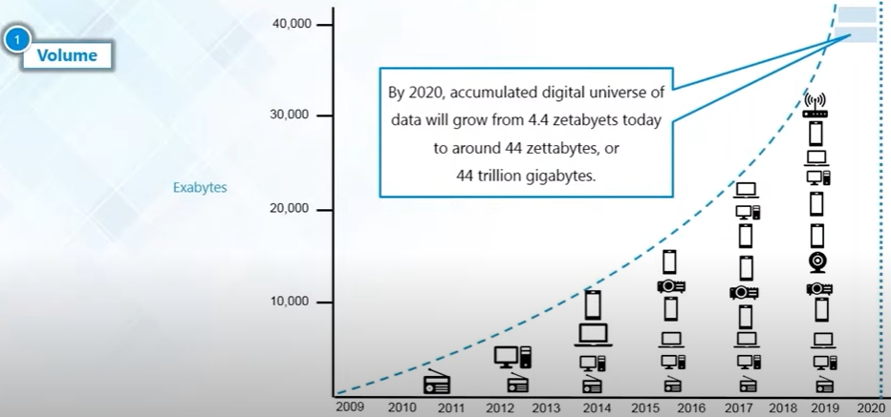

1. **Variety:**

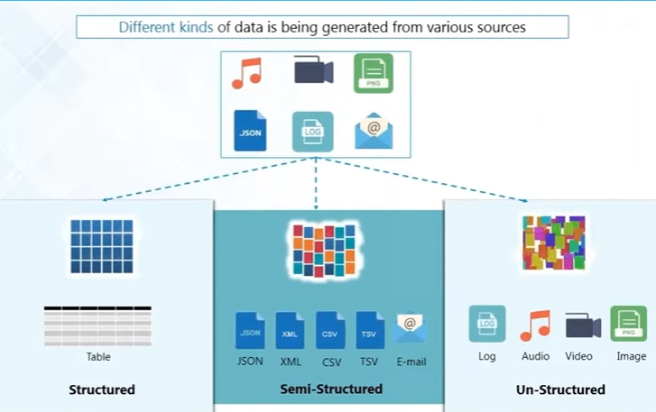

1. **Velocity:**

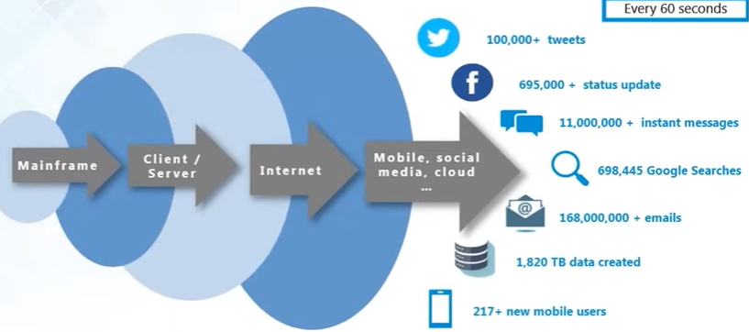

1. **Value:**

**Value of data, Importance of data, so that we can get valuable insight and it will be useful for business ideas**

1. **Veracity:**

**Data preprocessing, handling missing values, normalization**

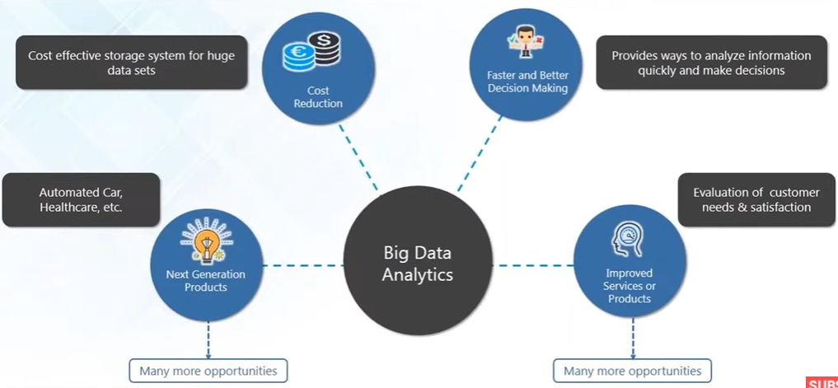

**IBM BIG DATA ANALYSTICS:**

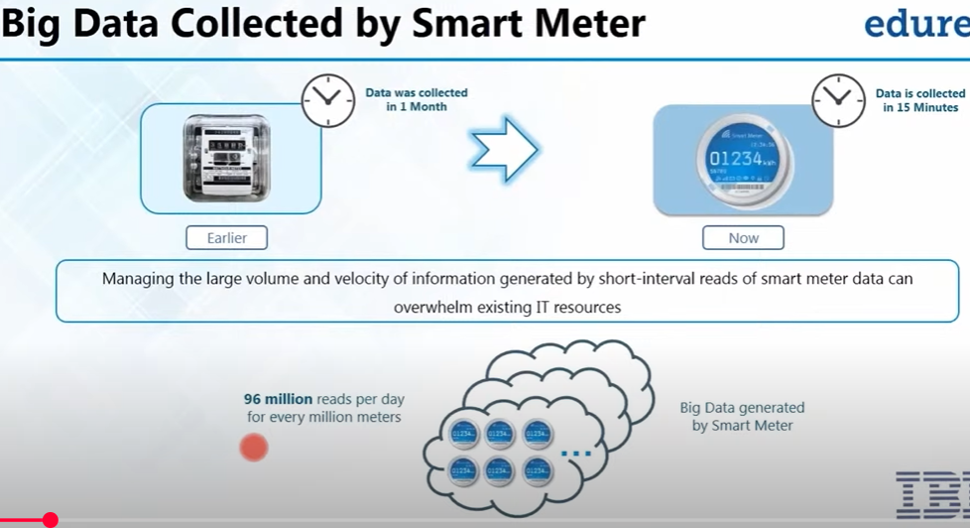

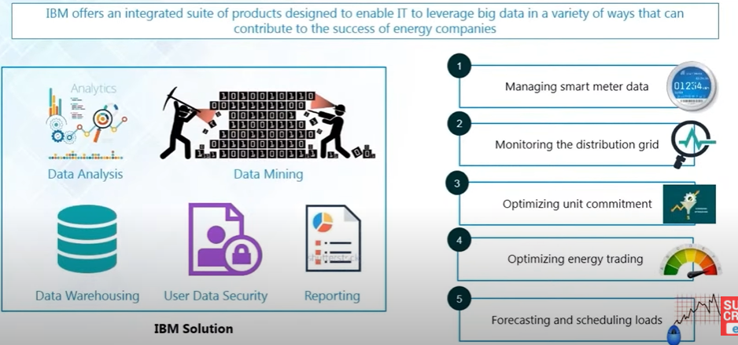

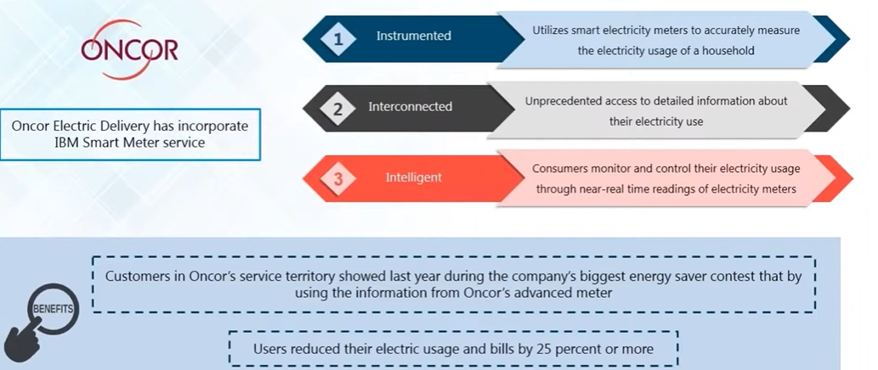

**Problems with BigData:**

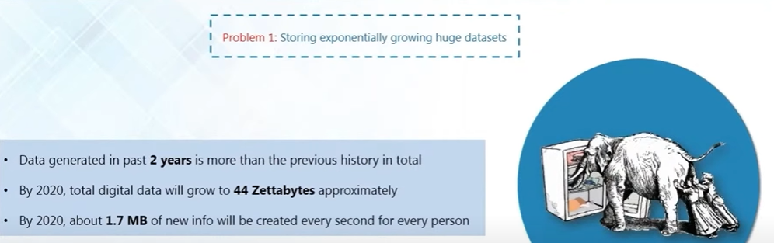

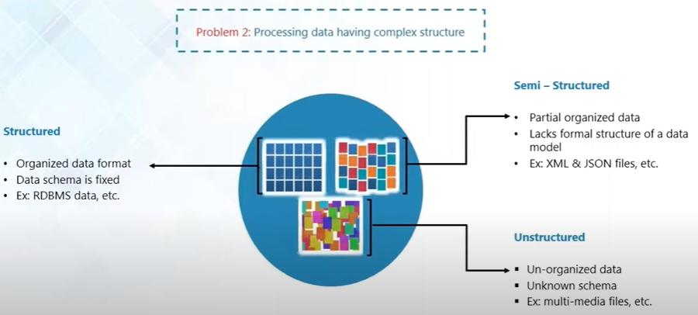

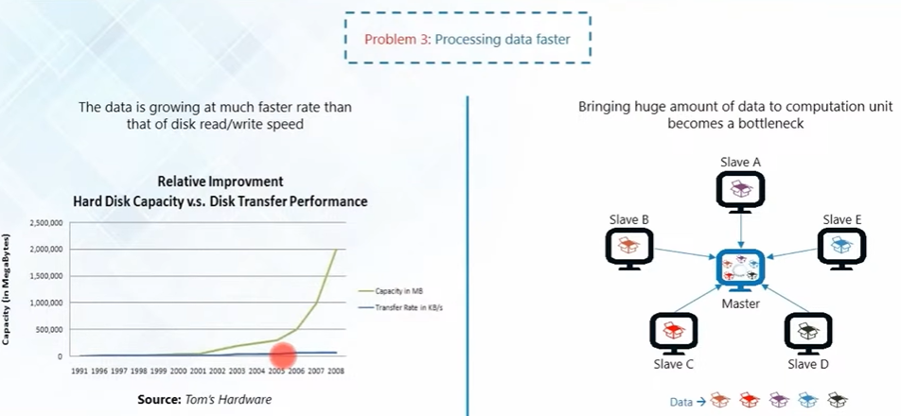

**Hadoop**

Hadoop is a framework that allows us to store and process large data sets in parallel and distributed fashion.

**HDFS(Storage):** Allows to dumpany kind of data across the cluster

**MapReduce(Processing):** Allows parallel processing of the data stored in HDFS.

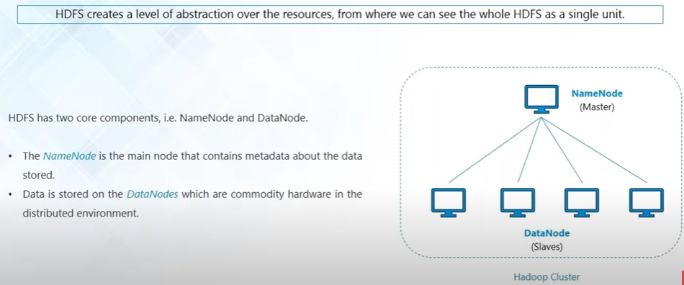

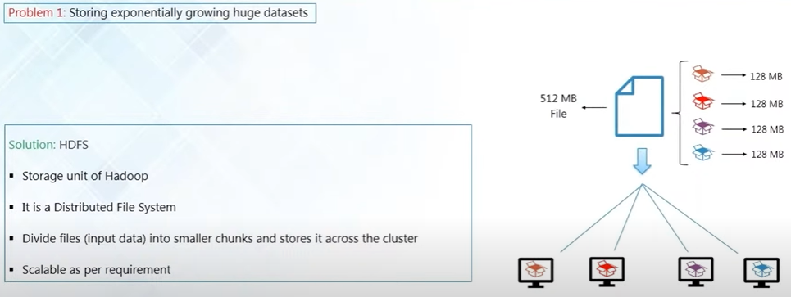

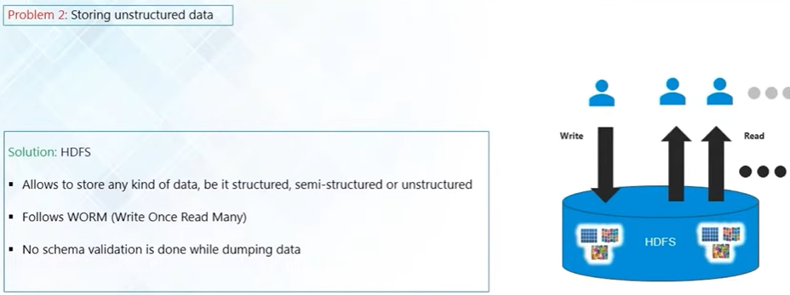

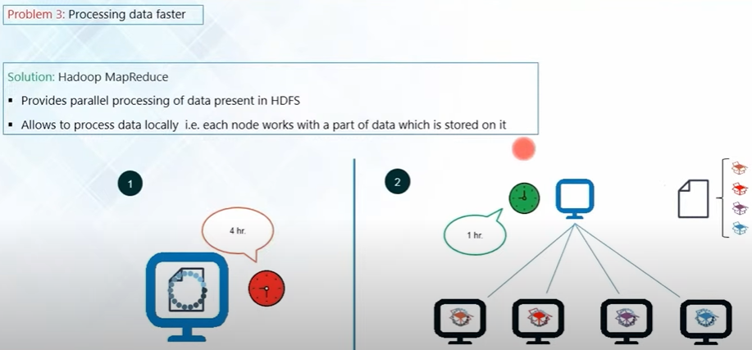

**Who is Big data Engineer?**

Data Engineers are one who Develops, constructs, Tests, maintain the complete artictecture of large scale processing system

**Work flow:**

**1. Collecting Data**

* Fetching raw data from different sources like databases, APIs, logs, or external files.
* Example: Getting YouTube video data using an API.

**2. Storing Data**

* Storing the collected data in a structured format using **SQL databases (PostgreSQL, MySQL)** or **Data Lakes (AWS S3, Hadoop)**.
* Example: Storing YouTube channel and video details in a PostgreSQL database.

**3. Processing & Cleaning Data**

* Removing duplicate, missing, or incorrect data.
* Transforming raw data into a usable format.
* Example: Converting date formats, handling missing values, or filtering out invalid records.

**4. Building Data Pipelines**

* Automating the data flow from source → storage → processing → final database.
* Example: Setting up an **ETL (Extract, Transform, Load) pipeline** to update new YouTube video details daily.

**5. Optimizing & Managing Databases**

* Ensuring the database runs efficiently, indexes are used correctly, and queries execute fast.
* Example: Creating indexes on video IDs to speed up search queries.

**6. Supporting Data Analysts & Scientists**

* Providing clean, structured, and accessible data for analysis and machine learning models.
* Example: Writing optimized SQL queries so that a Data Scientist can easily fetch data for predictions.

**7. Monitoring & Maintaining Pipelines**

* Ensuring data pipelines run smoothly without errors or failures.
* Example: Setting up alerts in case of data pipeline failures.

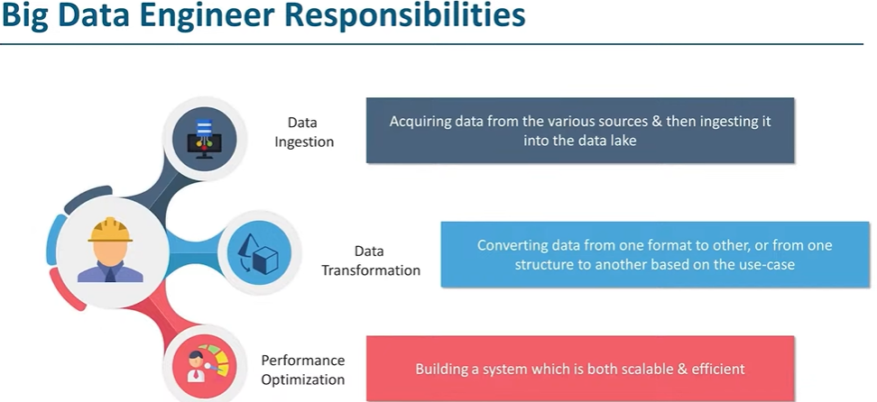

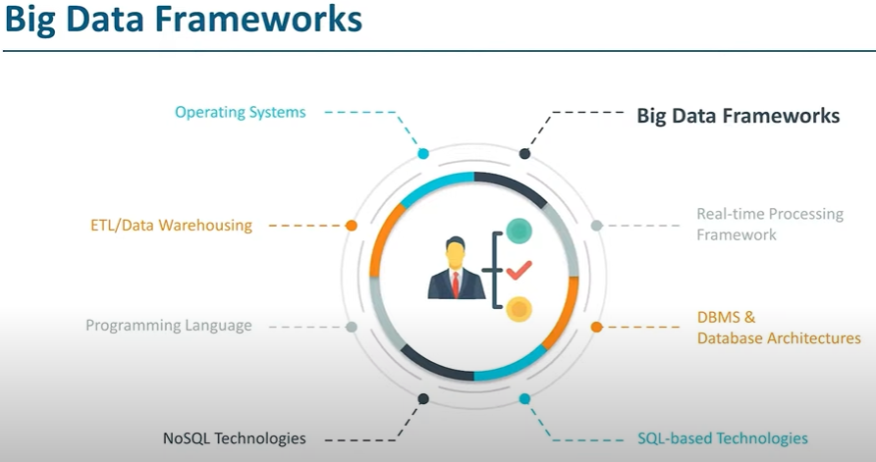

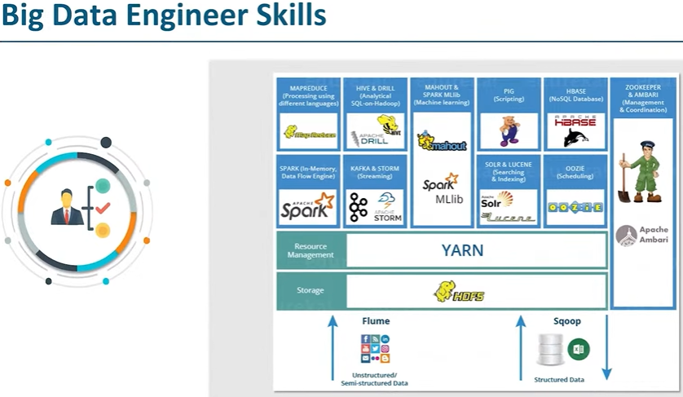

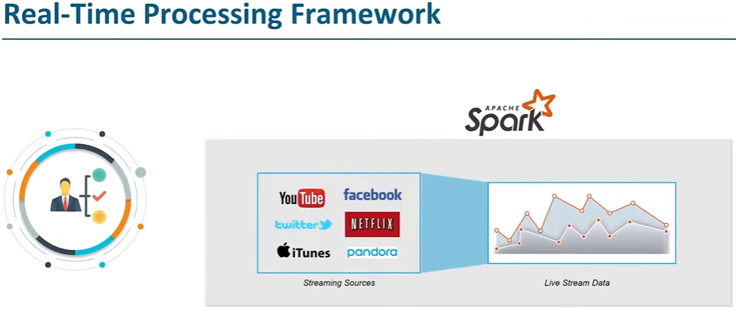

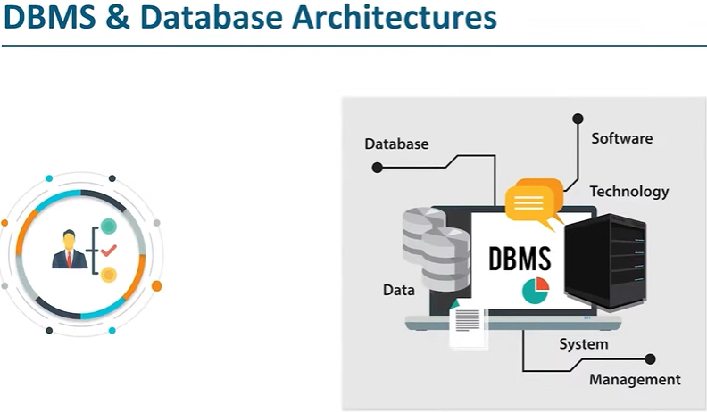

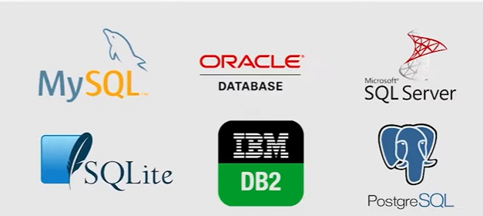



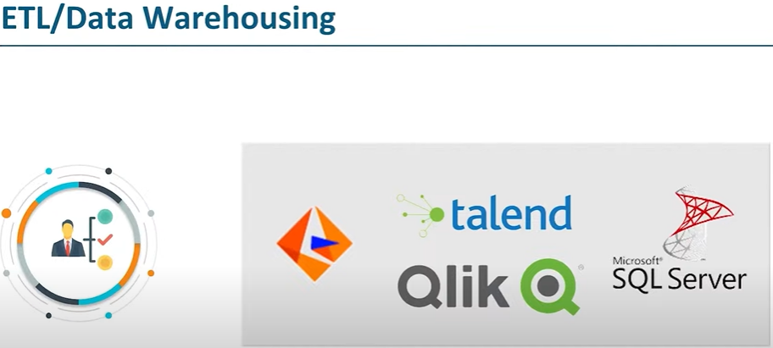

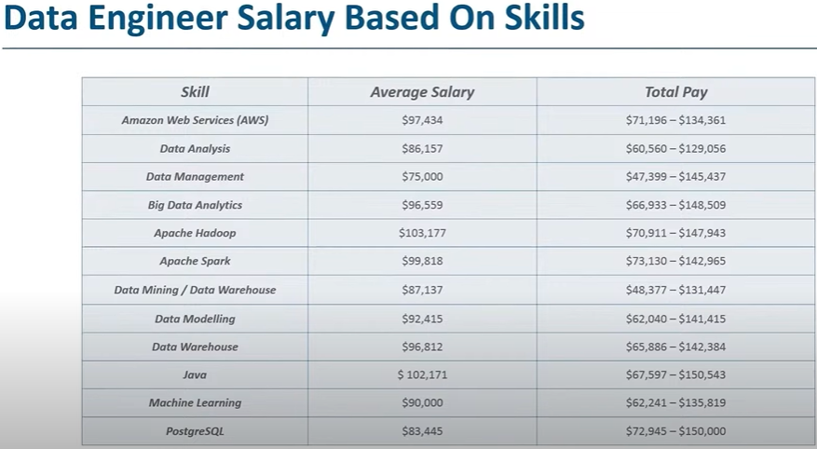

**AZURE DATA ENGINEER**

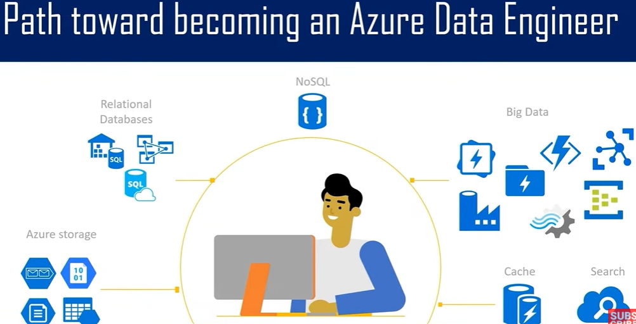

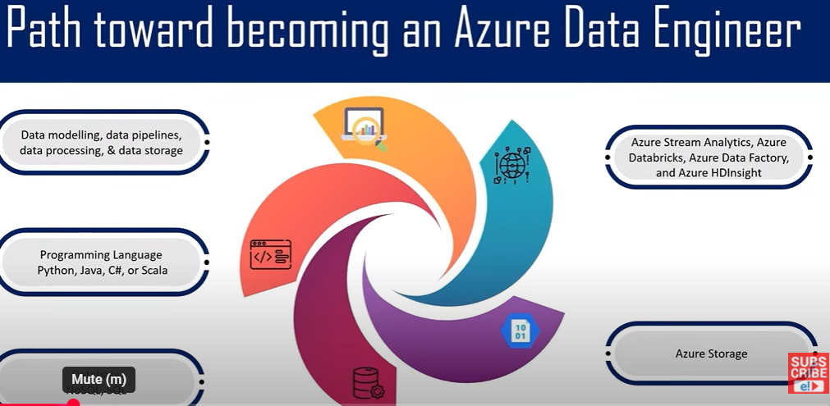

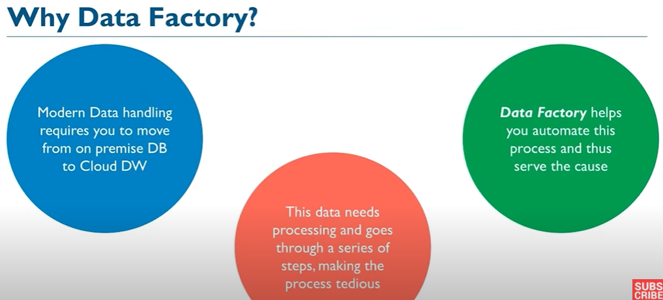

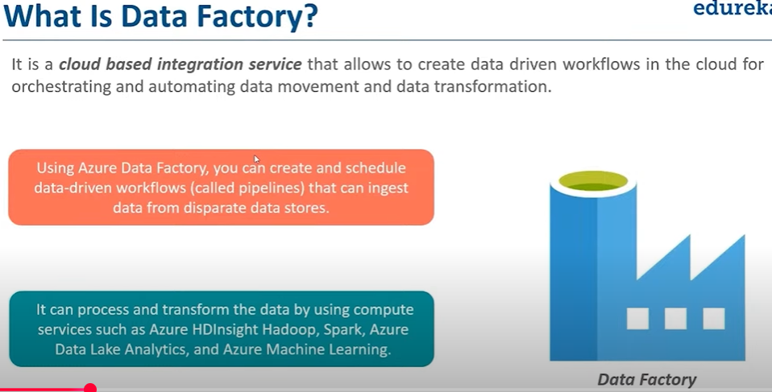

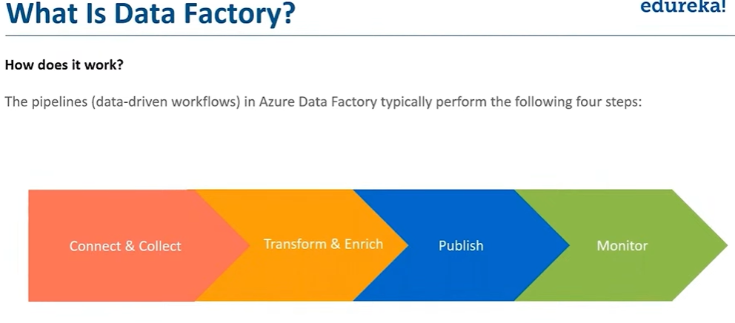

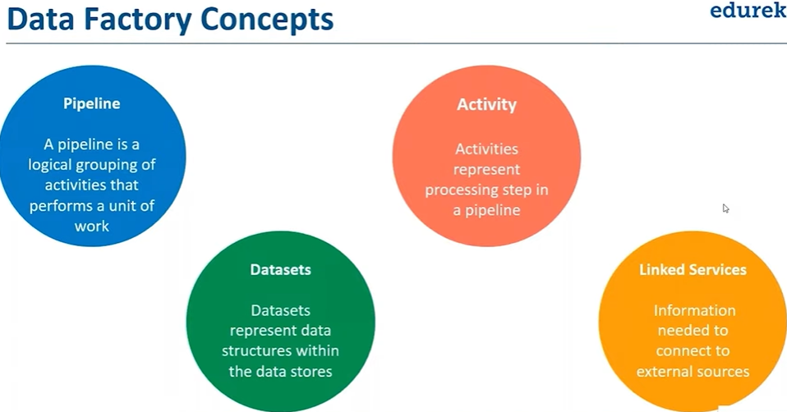

**Data Lake:**

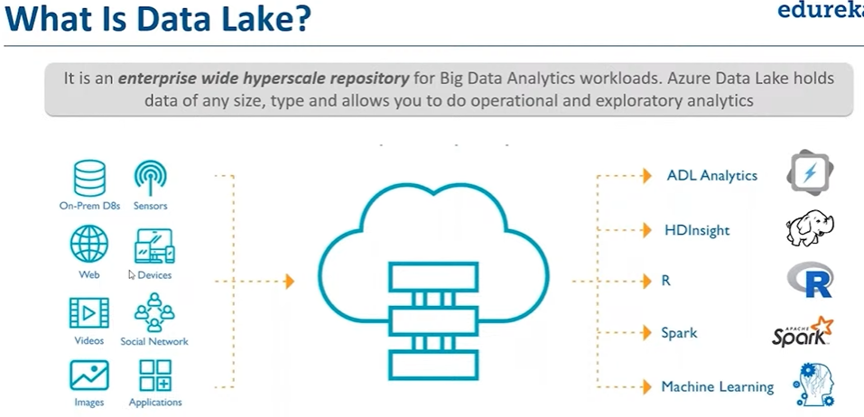

**Data Lake concepts:**

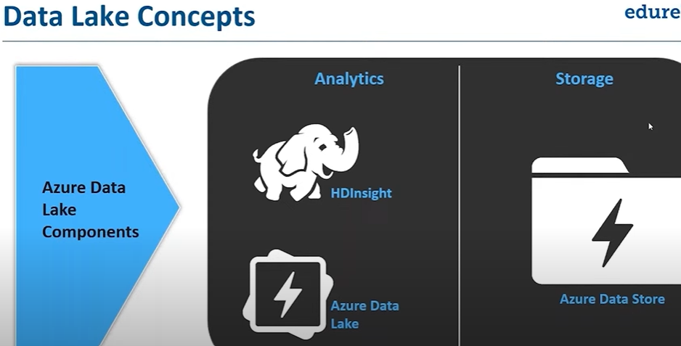

* 1. **Analytics on data of any size**
  2. **All users productive on day one**
  3. **Ready for your enterprise**

**Types of Data stored:**

1. **Structured data**
2. **Semi structured data**
3. **Unstructured data**

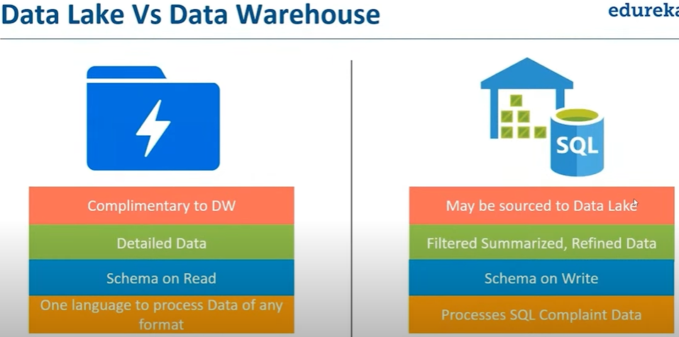

**Why Database?**

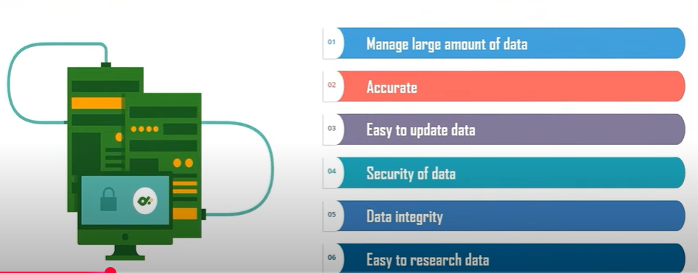

**What is database?**

A database is an organized collection of data, generally stored and accessed electronically from a computer system. Where database are more complex , they are often developed using formal design and modeling techniques.

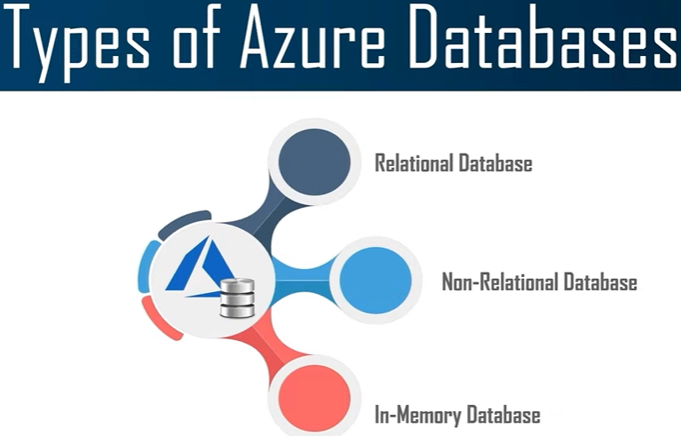

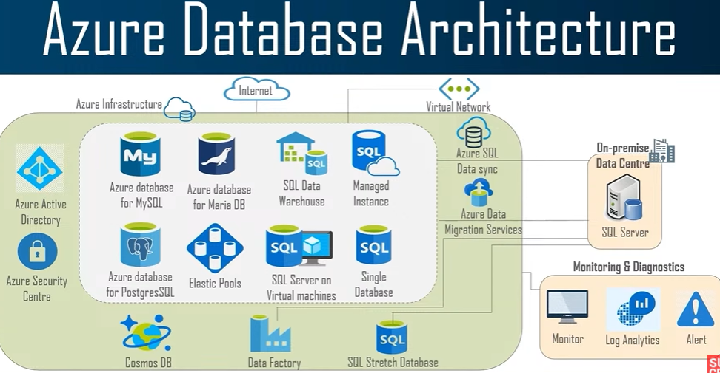

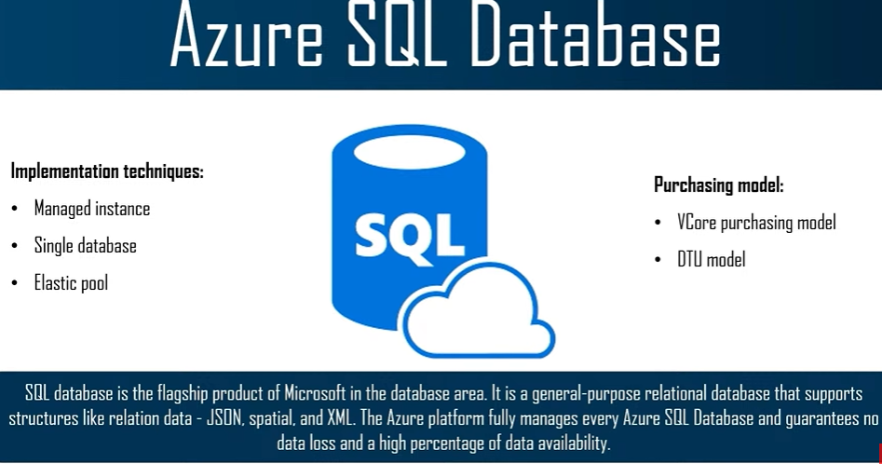

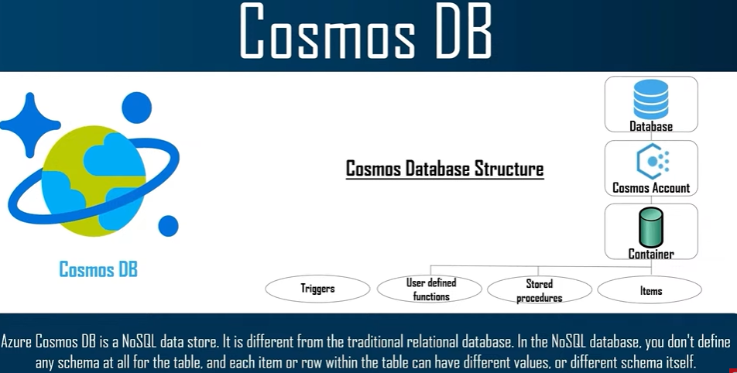

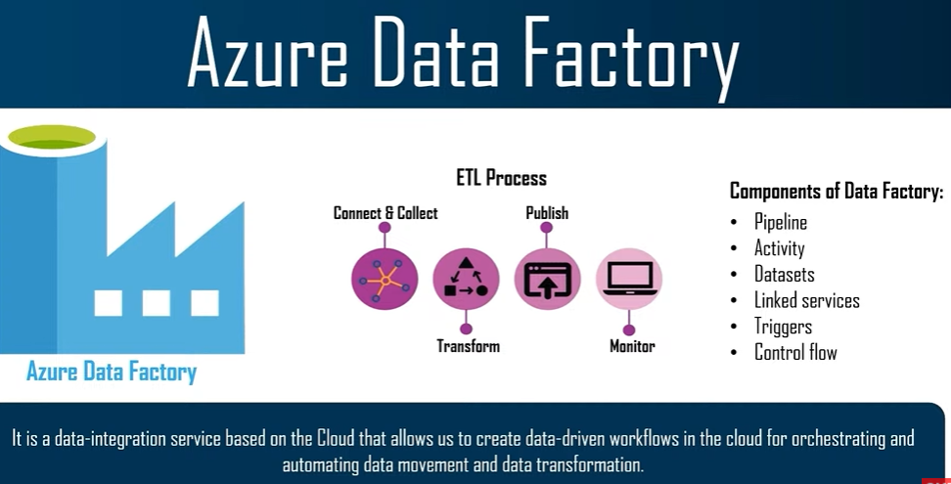

Use cases:

SQL Database:

* 1. Developer/Test environment
  2. Business continuity
  3. Scaling out read only work loads
  4. Backup & Restore
  5. Advanced analytics

Cosmos DB use cases:

1. IOT Telamtiques
2. Retail marketing
3. Gaming
4. Web applications

